Datagram

🧱 What Is a Datagram in Network Data Structures?
# Source: Chatgpt (GPT‑5 Mini) at [12/14/2025]
A datagram is a self-contained, independent unit of data that is sent across a network without establishing a connection. It typically refers to Layer 3 (IP) or Layer 4 (UDP) communication.

🧠 Simple Definition:
# Source: Chatgpt (GPT‑5 Mini) at [12/14/2025]
A datagram is a complete package of data that includes all the information needed for routing and delivery — no connection or handshake is required.

📚 Where It Fits (OSI Model):
# Source: Chatgpt (GPT‑5 Mini) at [12/14/2025]
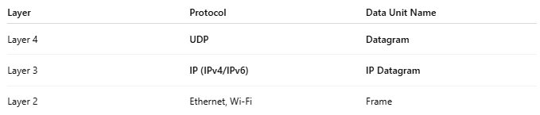
Layer | Protocol | Data Unit Name
Layer 4 | UDP | Datagram
Layer 3 | IP (IPv4/IPv6) | IP Datagram
Layer 2 | Ethernet, Wi-Fi | Frame

📦 Structure of an IP Datagram
# Source: Chatgpt (GPT‑5 Mini) at [12/14/2025]
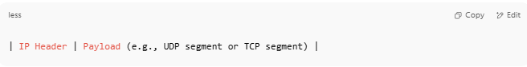
| IP Header | Payload (e.g., UDP segment or TCP segment) |

Example (IPv4 Datagram carrying UDP):
# Source: Chatgpt (GPT‑5 Mini) at [12/14/2025]
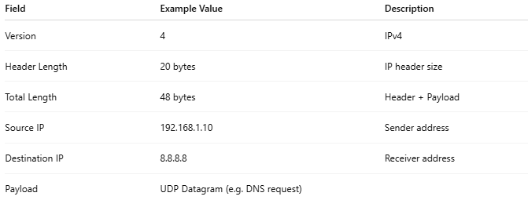
Field | Example Value | Description
Version | 4 | IPv4
Header Length | 20 bytes | IP header size
Total Length | 48 bytes | Header + Payload
Source IP | 192.168.1.10 | Sender address
Destination IP | 8.8.8.8 | Receiver address
Payload | UDP Datagram (e.g. DNS request)

🧩 Structure of a UDP Datagram (at Layer 4)
# Source: Chatgpt (GPT‑5 Mini) at [12/14/2025]
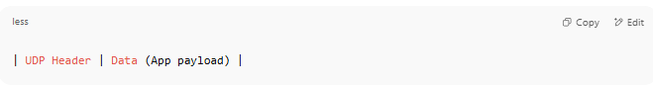
| UDP Header | Data (App payload) |

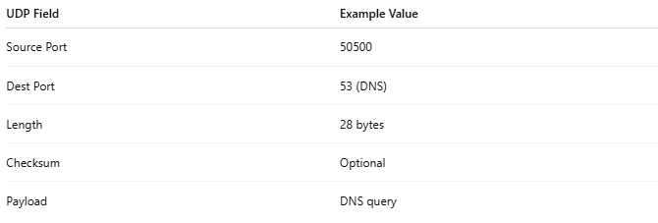
UDP Field | Example Value
Source Port | 50500
Dest Port | 53 (DNS)
Length | 28 bytes
Checksum | Optional
Payload | DNS query

🚀 Key Characteristics
# Source: Chatgpt (GPT‑5 Mini) at [12/14/2025]
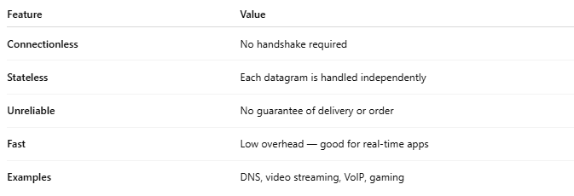
Feature | Value
Connectionless | No handshake required
Stateless | Each datagram is handled independently
Unreliable | No guarantee of delivery or order
Fast | Low overhead — good for real-time apps
Examples | DNS, video streaming, VoIP, gaming

🧱 Datagram – Visual Example
# Source: Chatgpt (GPT‑5 Mini) at [12/14/2025]
Certainly! Here's a 🧱 Visual Example of a Datagram, focusing on an IP Datagram (Layer 3) carrying a UDP Datagram (Layer 4) — a classic example of connectionless transmission, such as a DNS query.

🧠 Example: IP Datagram with UDP Inside
# Source: Chatgpt (GPT‑5 Mini) at [12/14/2025]
We're sending a DNS query from your computer to a DNS server (e.g., 8.8.8.8).

🧱 Full Structure
# Source: Chatgpt (GPT‑5 Mini) at [12/14/2025]
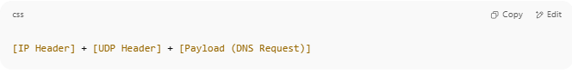
[IP Header] + [UDP Header] + [Payload (DNS Request)]

🧩 IP Header (Layer 3) – 20 Bytes
# Source: Chatgpt (GPT‑5 Mini) at [12/14/2025]
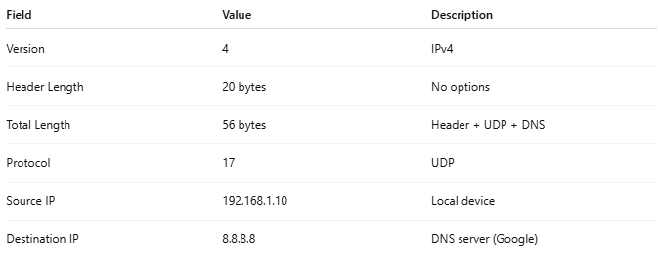
Field | Value | Description
Version | 4 | IPv4
Header Length | 20 bytes | No options
Total Length | 56 bytes | Header + UDP + DNS
Protocol | 17 | UDP
Source IP | 192.168.1.10 | Local device
Destination IP | 8.8.8.8 | DNS server (Google)
🟥 Hex (partial):
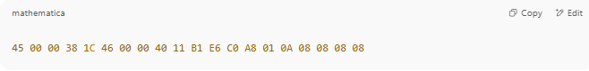
45 00 00 38 1C 46 00 00 40 11 B1 E6 C0 A8 01 0A 08 08 08 08

🧩 UDP Header (Layer 4) – 8 Bytes
# Source: Chatgpt (GPT‑5 Mini) at [12/14/2025]
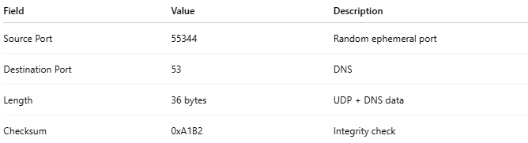

Field | Value | Description
Source Port | 55344 | Random ephemeral port
Destination Port | 53 | DNS
Length | 36 bytes | UDP + DNS data
Checksum | 0xA1B2 | Integrity check
🟥 Hex:
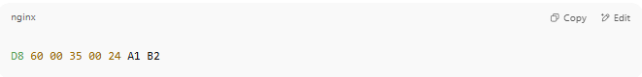
D8 60 00 35 00 24 A1 B2

🟩 Payload – DNS Query (Application Data)
# Source: Chatgpt (GPT‑5 Mini) at [12/14/2025]
Data Type | Value
Query | "A record for google.com"
🟢 DNS Payload (partial hex):
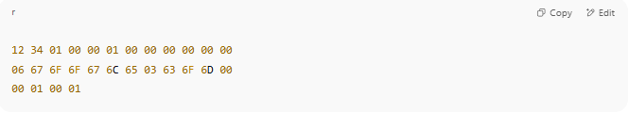
12 34 01 00 00 01 00 00 00 00 00 00
06 67 6F 6F 67 6C 65 03 63 6F 6D 00
00 01 00 01

🧾 Combined Datagram (Hex)
# Source: Chatgpt (GPT‑5 Mini) at [12/14/2025]
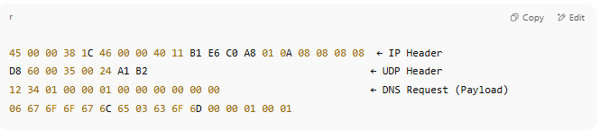
45 00 00 38 1C 46 00 00 40 11 B1 E6 C0 A8 01 0A 08 08 08 08 ← IP Header
D8 60 00 35 00 24 A1 B2 ← UDP Header
12 34 01 00 00 01 00 00 00 00 00 00 ← DNS Request (Payload)
06 67 6F 6F 67 6C 65 03 63 6F 6D 00 00 01 00 01

✅ Visual Summary
# Source: Chatgpt (GPT‑5 Mini) at [12/14/2025]
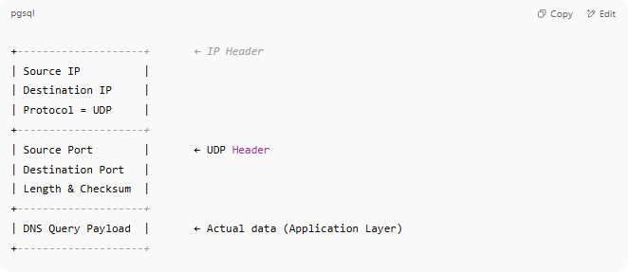
+--------------------+ ← IP Header
| Source IP |
| Destination IP |
| Protocol = UDP |
+--------------------+
| Source Port | ← UDP Header
| Destination Port |
| Length & Checksum |
+--------------------+
| DNS Query Payload | ← Actual data (Application Layer)
+--------------------+

✅ Key Takeaways
# Source: Chatgpt (GPT‑5 Mini) at [12/14/2025]
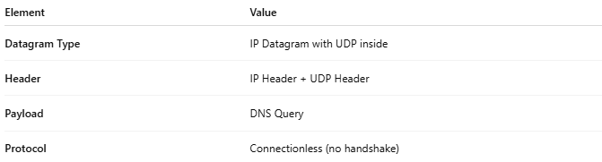

Element | Value
Datagram Type | IP Datagram with UDP inside
Header | IP Header + UDP Header
Payload | DNS Query
Protocol | Connectionless (no handshake)

🆚 Datagram vs Segment
# Source: Chatgpt (GPT‑5 Mini) at [12/14/2025]
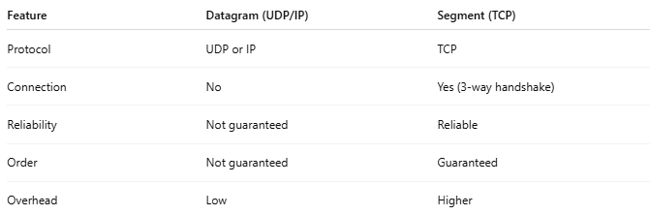
Feature | Datagram (UDP/IP) | Segment (TCP)
Protocol | UDP or IP | TCP
Connection | No | Yes (3-way handshake)
Reliability | Not guaranteed | Reliable
Order | Not guaranteed | Guaranteed
Overhead | Low | Higher

✅ Summary
# Source: Chatgpt (GPT‑5 Mini) at [12/14/2025]
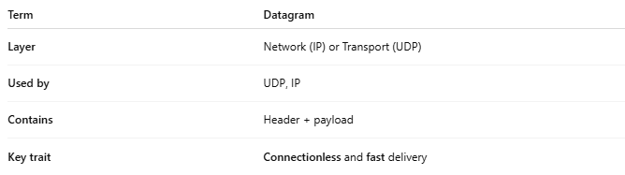
Term | Datagram
Layer | Network (IP) or Transport (UDP)
Used by | UDP, IP
Contains | Header + payload
Key trait | Connectionless and fast delivery

